Project Report
Electric Vehicle Market Performance & Insights
Date | 02 November 2026
Team ID | [Enter Team ID]
Project Name | Electric Vehicle Market Performance & Insights
Maximum Marks | —

Submitted by: Rajlaxmi Pandey | Program: Data Analytics with Tableau (SkillWallet) | Domain: Transportation | Type: Individual
Tableau Public: https://public.tableau.com/app/profile/rajlaxmi.pandey/viz/Book2_17936085689820/Story1
GitHub: https://github.com/rajlaxmipandey752-collab/ev-market-insights

1. INTRODUCTION
1.1 Project Overview
The electric vehicle (EV) industry is one of the fastest-growing sectors of the global automotive market, driven by environmental awareness, government incentives and advances in battery technology. This project analyses the Kaggle ‘Electric Vehicle Market Classification Dataset’ – 200,000 EV models (train split, 300,000 in total) described by 37 attributes such as category, manufacturer, manufacturing country, battery type and capacity, driving range, charging, price, insurance, resale value, annual sales and customer rating – using Python for data preparation and Tableau for analysis. The result is the ‘EV Market Executive Overview’ dashboard and a 5-point story published on Tableau Public and embedded in a Flask web application.
1.2 Purpose
The purpose is to give market strategists, business-intelligence managers and sustainability researchers one interactive, visual view of EV market performance so they can identify the categories that drive sales, the leading manufacturers, battery-technology adoption, driving-range differences, global manufacturing distribution and customer satisfaction, and make faster, evidence-based decisions.
2. IDEATION PHASE
2.1 Problem Statement
PS | I am (Customer) | I’m trying to | But | Because | Which makes me feel
PS-1 | Emily Johnson, EV Market Strategy Director | understand category sales, leading manufacturers and satisfaction by segment | data for 200,000 models is spread across large files | no single interactive dashboard exists | overwhelmed and slow to decide
PS-2 | David Chen, Automotive BI Manager | compare manufacturer share, battery distribution and countries | 200 manufacturers have very similar shares | KPIs are not pre-calculated or visualised | frustrated
PS-3 | Dr. Sarah Williams, Sustainable Mobility Researcher | compare battery technologies, range and ratings | data has nulls and sits in separate columns | raw data is not cleaned or aggregated | concerned about evidence quality

2.2 Empathy Map Canvas
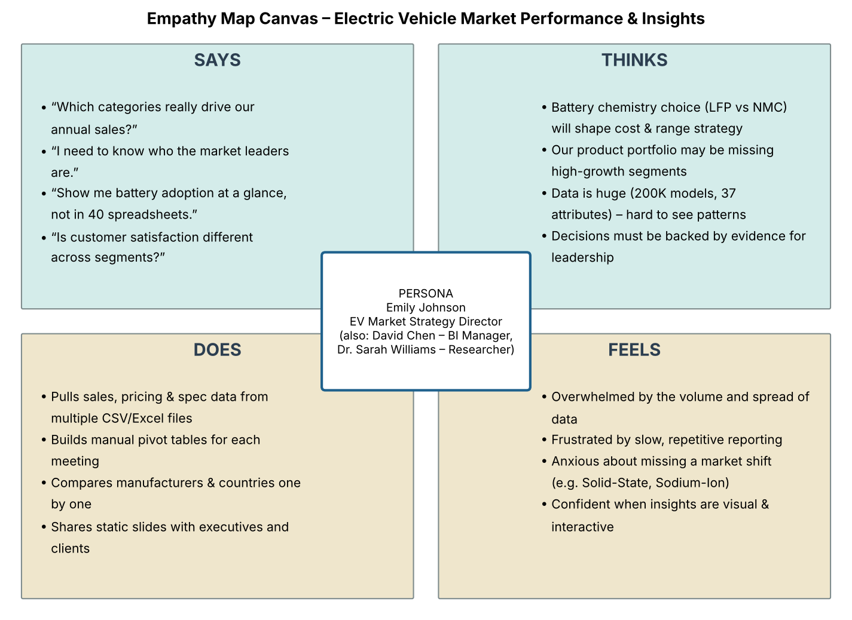
Figure 2.1 – Empathy map for the primary persona
2.3 Brainstorming
Thirteen ideas were listed and grouped into eight themes. The executive dashboard, battery & range analysis, geography & trend, customer satisfaction, story and web integration were selected; ML prediction and a real-time data feed were moved to future scope.
Group | Idea | Feasibility | Importance | Selected
G1 | Executive overview dashboard (KPIs, category sales, Top-10) | High | High | Yes
G2 | Battery technology & driving range analysis | High | High | Yes
G3 | Manufacturing map & yearly trend | High | Medium | Yes
G4 | Customer satisfaction & ownership cost | High | High | Yes
G5 | Tableau Story | High | High | Yes
G6 | Flask web integration | Medium | Medium | Yes
G7 | ML category prediction | Medium | Low | No
G8 | Real-time data feed | Low | Medium | No

3. REQUIREMENT ANALYSIS
3.1 Customer Journey Map
Stage | Actions | Touchpoints | Feeling | Opportunity
1. Discover & Access | Opens Tableau Public / Flask link, reads KPI summary | Home page, KPI Summary | Curious, slightly overwhelmed | Guided landing page, fast load
2. Explore & Analyse | Uses % of sales and battery filters, compares charts | Executive Overview dashboard | Engaged, in control | Top-N / metric parameters, drill-down
3. Decide & Share | Walks through story, shares insights | Story 1, Share/Download, GitHub | Confident | PDF export, scheduled refresh

3.2 Solution Requirement
FR No. | Functional Requirement | Sub-requirement
FR-1 | Data Access & Integration | Load Kaggle EV CSVs (200K/100K rows, 37 cols) into Tableau extract
FR-2 | Data Processing | Dedupe, trim, group-median imputation, derived bands and ratios
FR-3 | Business Analysis | Total Sales, Market Share %, Avg Rating, Avg Range, Top-10 ranking
FR-4 | Insights & Outputs | 9 worksheets, 1 dashboard, 1 story (5 points)
FR-5 | User Interaction | % of Total Annual Sales slider, Battery Type filter, highlights, tooltips
FR-6 | Data Update & Reporting | Re-run script, refresh extract, republish; Flask shows latest views

NFR | Requirement | Description
NFR-1 | Usability | Clear layout, consistent colours, readable by non-technical users
NFR-2 | Security | Public synthetic data only; credentials not stored in code
NFR-3 | Reliability | 0 nulls/duplicates; KPIs validated against pandas totals
NFR-4 | Performance | Extract-based; views render < 3 s
NFR-5 | Availability | 24×7 on Tableau Public; code on GitHub
NFR-6 | Scalability | Supports 300K+ rows; can move to Tableau Cloud / warehouse

3.3 Data Flow Diagram
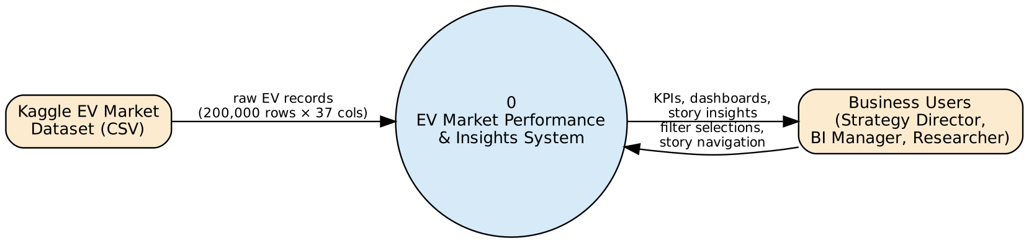
Figure 3.1 – DFD Level 0
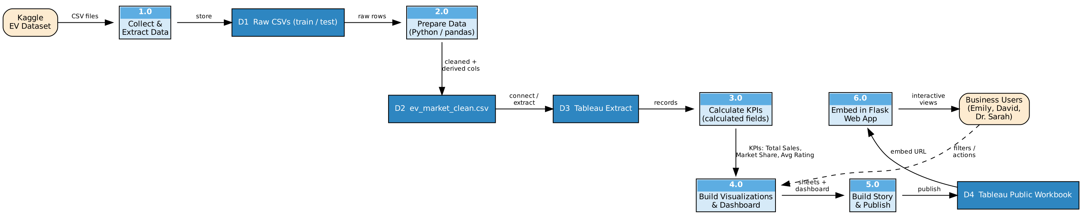
Figure 3.2 – DFD Level 1
3.4 Technology Stack
Component | Technology
Programming / Query Language | Python 3 (pandas, NumPy), Tableau calculations, HTML/CSS/Jinja2
Database / Data Store | CSV files + Tableau extract
Data Ingestion | Kaggle download → Tableau text-file connection (extract)
Transformation & Business Logic | data_preparation.py; Tableau calculated fields & table calculations
Visualization / Analytics | Tableau Public (dashboard, story)
Front-End / UI | Tableau Public, Flask web app (Tableau Embedding API v3), GitHub

4. PROJECT DESIGN
4.1 Problem Solution Fit
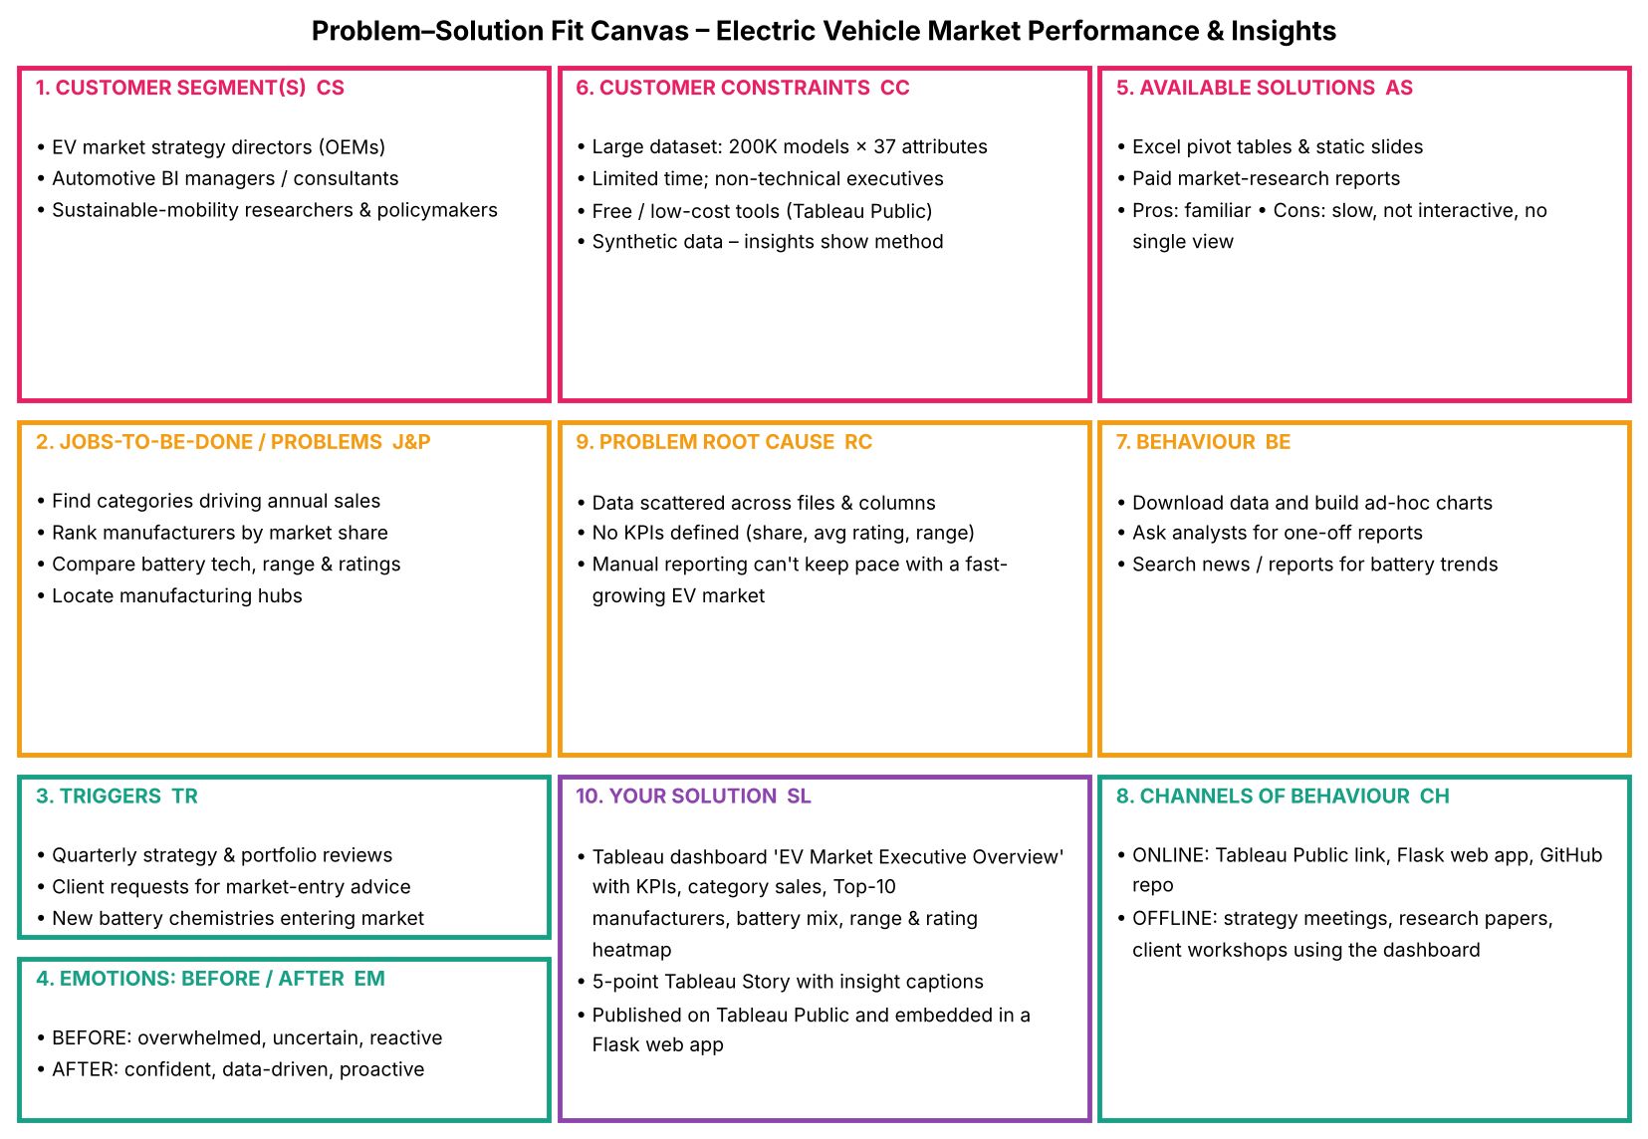
Figure 4.1 – Problem–Solution Fit canvas
4.2 Proposed Solution
Item | Description
Objective | Interactive Tableau dashboard and story analysing EV sales, manufacturers, battery technology, range, geography and satisfaction
Problem | Stakeholders lack a single, interactive view of a large EV dataset
Approach | Kaggle CSV → Python cleaning → Tableau KPIs & sheets → dashboard & story → Tableau Public → Flask
Key Features | KPI summary, category sales, Top-10 manufacturers, battery pie, range charts, trend, map, rating heatmap, filters, 5-point story
Resources | MacBook Air (8 GB RAM), Tableau Public Desktop 2026.3, Python 3, VS Code, Git/GitHub

4.3 Solution Architecture
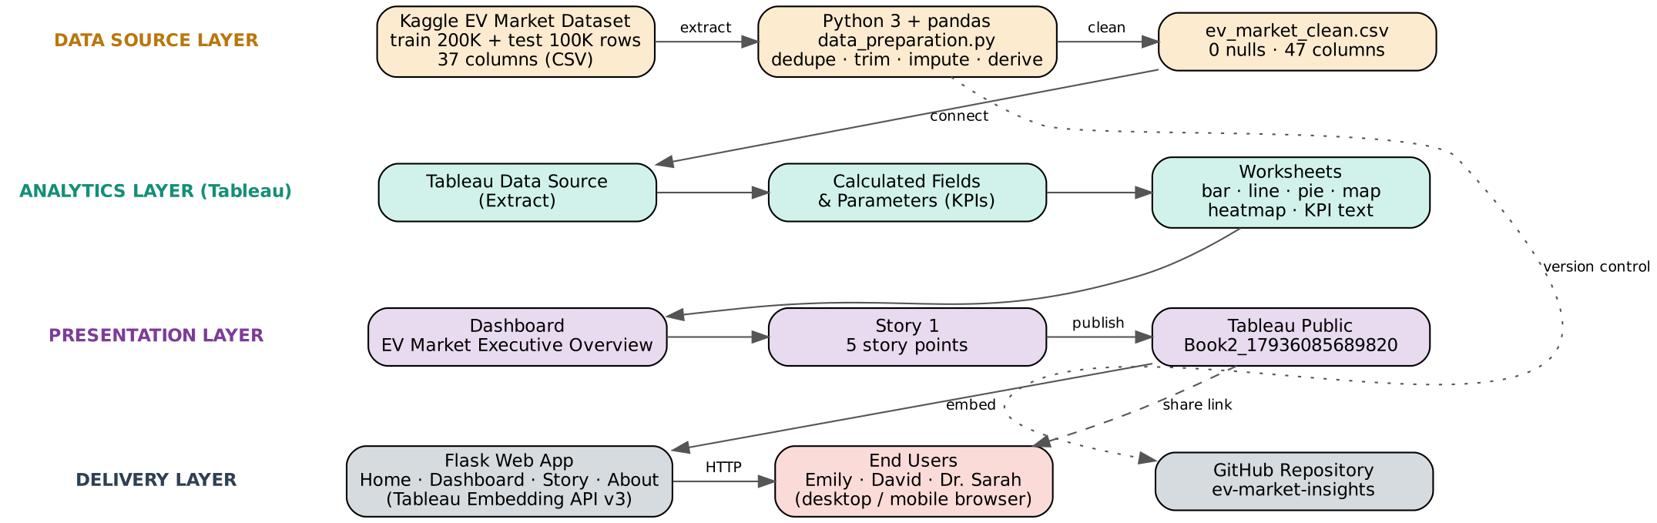
Figure 4.2 – Solution architecture
5. PROJECT PLANNING & SCHEDULING
5.1 Project Planning
The work was organised in 4 sprints of 4 days (18 Oct – 02 Nov 2026), 20 story points each (80 in total), giving an average velocity of 5 story points per day.
Sprint | Epics | Story Points | Start | End | Completed
Sprint-1 | Data Collection & Extraction, Data Preparation | 20 | 18 Oct 2026 | 21 Oct 2026 | 20
Sprint-2 | Data Visualizations | 20 | 22 Oct 2026 | 25 Oct 2026 | 20
Sprint-3 | Dashboard, Story | 20 | 26 Oct 2026 | 29 Oct 2026 | 20
Sprint-4 | Performance Testing, Web Integration, Documentation | 20 | 30 Oct 2026 | 02 Nov 2026 | 20

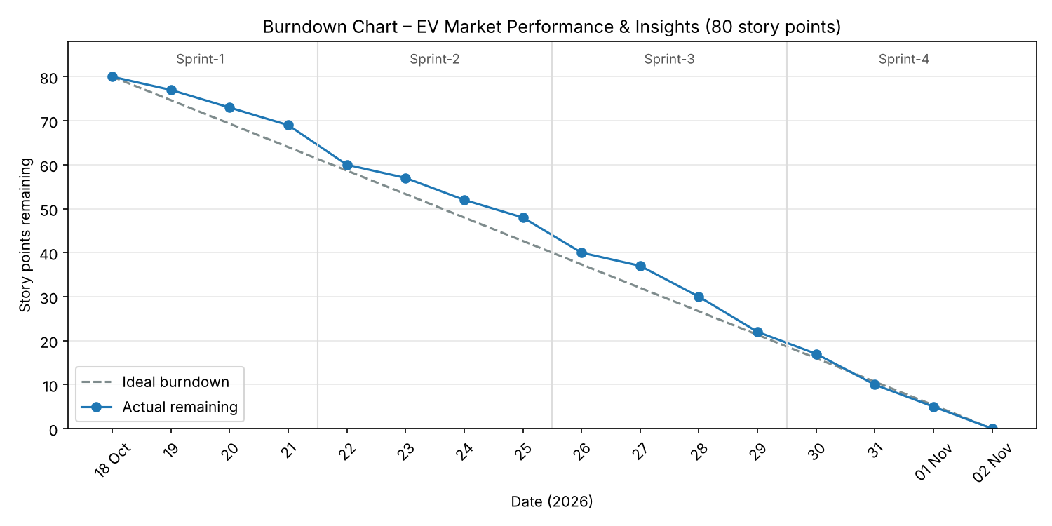
Figure 5.1 – Burndown chart
6. FUNCTIONAL AND PERFORMANCE TESTING
6.1 Performance Testing
Parameter | Result
Data Rendered | 200,000 rows × 37 columns (46.5 MB CSV) as extract; 1,550,703,961 sales units; workbook ≈ 11.2 MB
Data Preprocessing | 1 duplicate removed; 18,996 nulls in 5 columns imputed with group medians; 8 derived fields; 0 nulls after
Utilization of Filters | % of Total Annual Sales slider, Battery Type filter/legend, Top-10 manufacturer filter, rating colour legend, highlights
Calculation Fields Used | Total Annual Sales, Market Share %, % of Total Annual Sales, Avg Customer Rating, Avg Range, Total Range, Manufacturer Rank / Top-10
Dashboard Design | 1 dashboard with 8 visualisations
Story Design | 1 story with 5 story points

Functional testing: every filter and legend was checked to update all dependent sheets; totals in Tableau were cross-checked with pandas (e.g. total sales 1,550,703,961; NMC share 33.80%; India 159.2 M units).
7. RESULTS
7.1 Output Screenshots
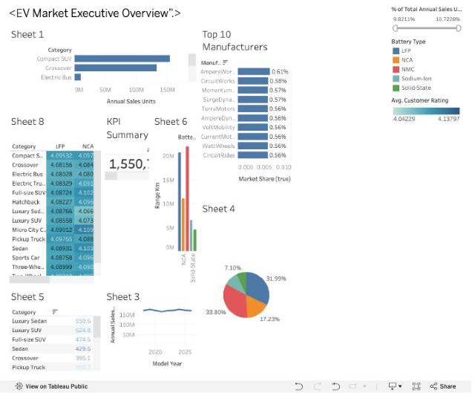
Figure 7.1 – EV Market Executive Overview dashboard
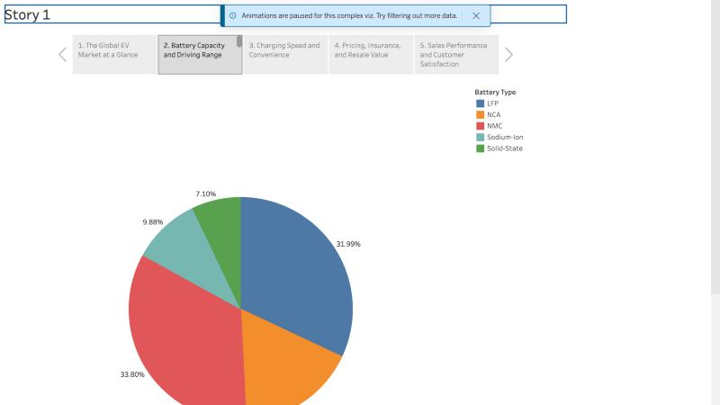
Figure 7.2 – Story point 2: battery-type share
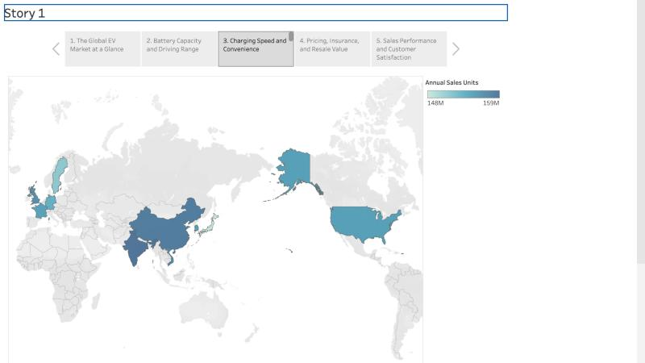
Figure 7.3 – Story point 3: annual sales by manufacturing country
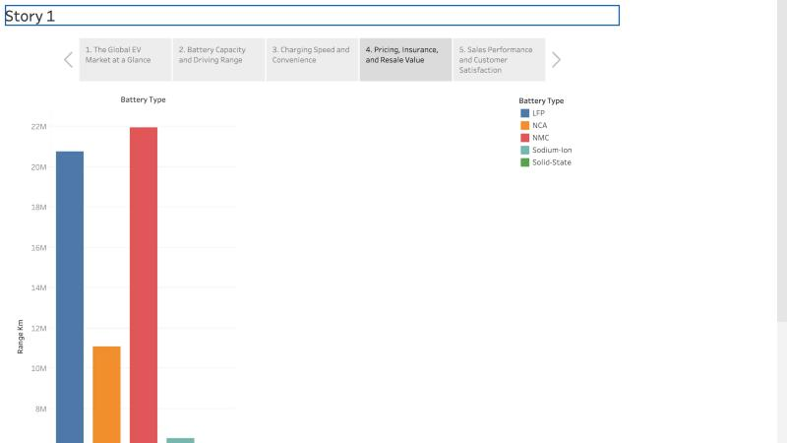
Figure 7.4 – Story point 4: total range by battery type
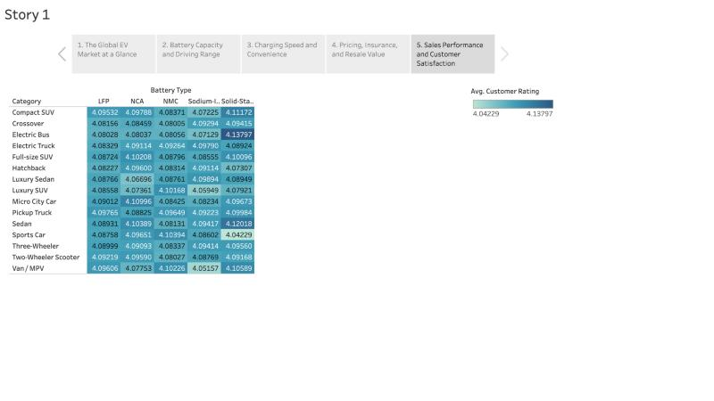
Figure 7.5 – Story point 5: customer rating by category × battery type
Key insights
Category sales: Two-Wheeler Scooters lead with 174.6 M units (11.3%); Hatchback 154.9 M, Compact SUV and Sedan 153.4 M; trucks, pickups and buses < 1% each.
Manufacturers: AmpereWorks leads with 0.61%; the Top 10 of 200 manufacturers hold only 5.7% – a highly fragmented market.
Battery technology: NMC 33.8% and LFP 32.0% dominate; NCA 17.2%; Sodium-Ion 9.9% and Solid-State 7.1% are emerging. Solid-State has the longest cycle life (~3,000) and lowest 5-year degradation (7.4%).
Range: Luxury Sedan (550.6 km) and Luxury SUV (524.8 km) offer the longest average range; Two-Wheeler Scooter the shortest (105 km). Average range across all EVs is 324.5 km.
Geography: Production is spread evenly across 10 countries (148–159 M units), led by India and China.
Customer satisfaction: Average rating is 4.09/5; 57.7% of models are rated ‘Excellent’ (≥ 4). Ratings vary narrowly from 4.04 to 4.14 and are not driven by price.
Trend: Annual sales are stable at 166–177 M units per model year from 2018 to 2026.
8. ADVANTAGES & DISADVANTAGES
Advantages
• Single interactive view of 200,000 EV models for strategy, BI and research users.
• Reproducible data preparation in Python; clean, null-free data for Tableau.
• Free to publish and share via Tableau Public; embedded in a web app.
• Story format makes insights easy to present to executives and clients.
Disadvantages
• Dataset is synthetic (fictional manufacturers/models) – insights demonstrate the method rather than real-market facts.
• Manual refresh and republish needed when data changes.
• Tableau Public makes the data public and offers no row-level security.
• Large dashboard requires scrolling on small screens.
9. CONCLUSION
The project turned a large EV market dataset into an interactive Tableau dashboard and story that answer the key questions of all three personas. Emily can see which categories drive sales and how satisfaction varies; David can compare manufacturer share, battery distribution and manufacturing countries; Dr. Sarah can compare battery technologies, range and ratings. The analysis shows a fragmented market led by two-wheelers and mainstream passenger cars, NMC/LFP battery dominance with emerging Solid-State and Sodium-Ion chemistries, evenly distributed global manufacturing and consistently good customer satisfaction.
10. FUTURE SCOPE
• Use real EV registration and sales data with automated, scheduled refresh.
• Add forecasting and ML classification of vehicle category / segment.
• Add Top-N and metric-selector parameters and drill-down from category to model.
• Add charging-infrastructure and CO₂-impact analysis; deploy on Tableau Cloud with row-level security.
11. APPENDIX
Item | Link / Details
Source Code | https://github.com/rajlaxmipandey752-collab/ev-market-insights (app.py, data_preparation.py, templates/, static/, tableau/TABLEAU_BUILD_GUIDE.md, docs/)
Dataset Link | https://www.kaggle.com/datasets/tharishreddy22/electric-vehicle-market-classification-dataset
GitHub | https://github.com/rajlaxmipandey752-collab/ev-market-insights
Project Demo (Tableau Public) | https://public.tableau.com/app/profile/rajlaxmi.pandey/viz/Book2_17936085689820/Story1
Demo Video | [Paste your demo video link]

